1 & 2. Screenshots & Explanation:
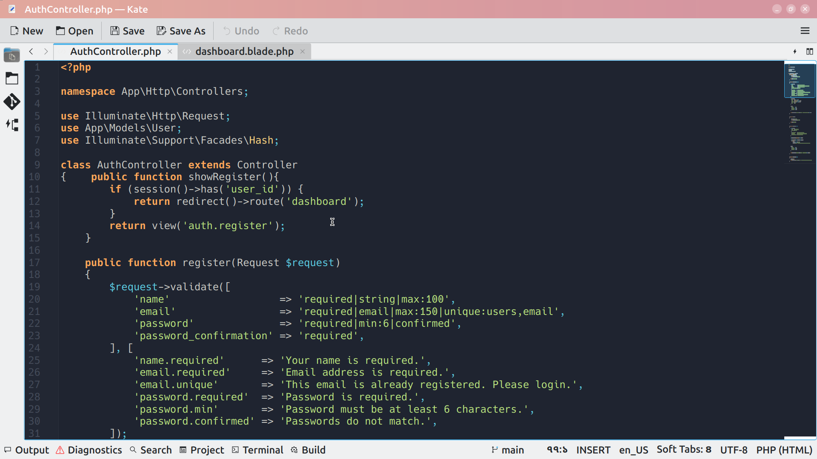
This page of code is indicating user dashboard first user will see registration page ig not login yet.

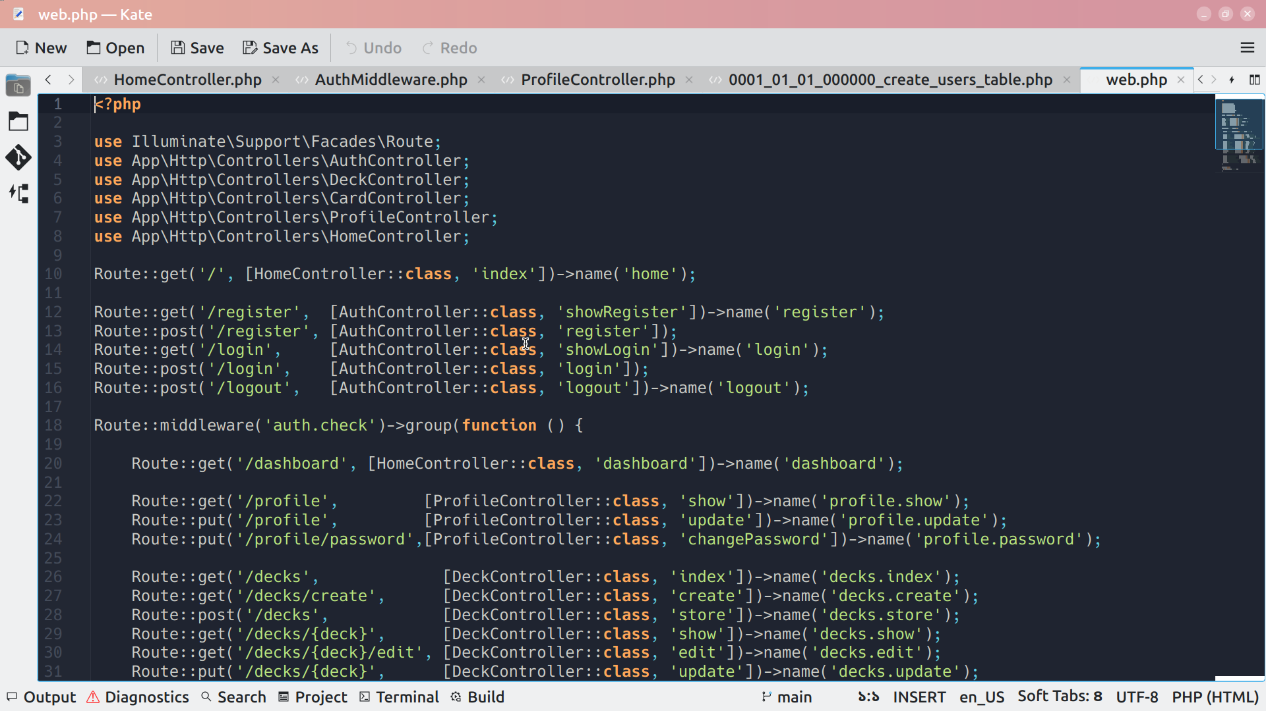
This is important code because project start from here, here it check user registered or not if not he can’t access dashboard.
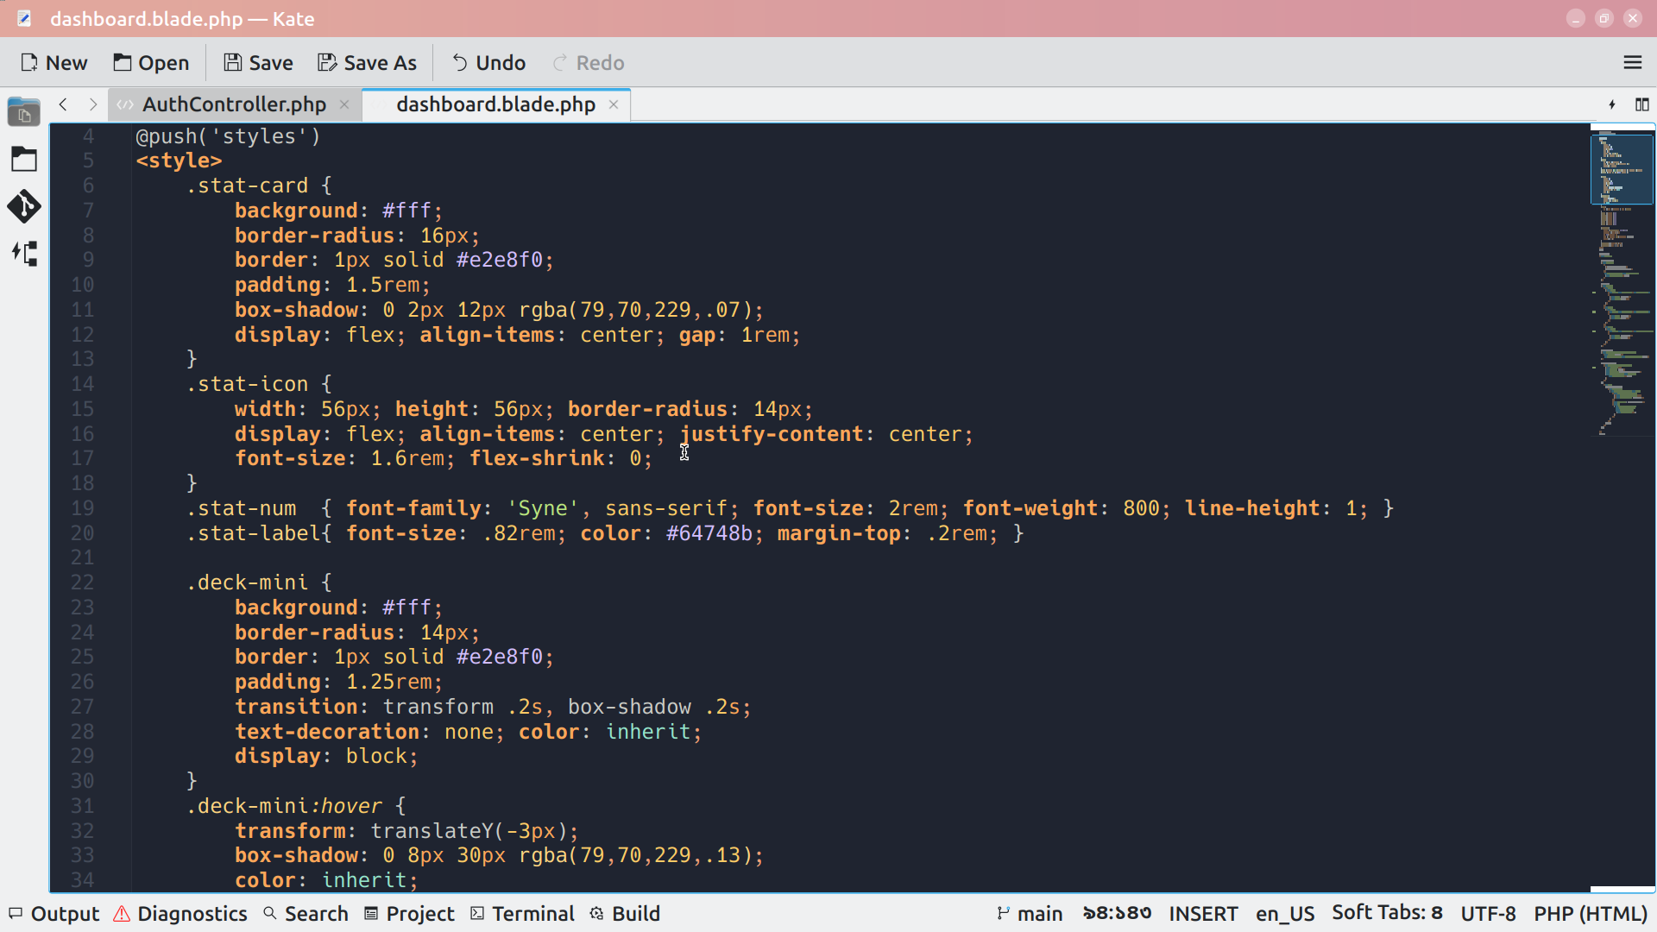
User will see his record in dashboard.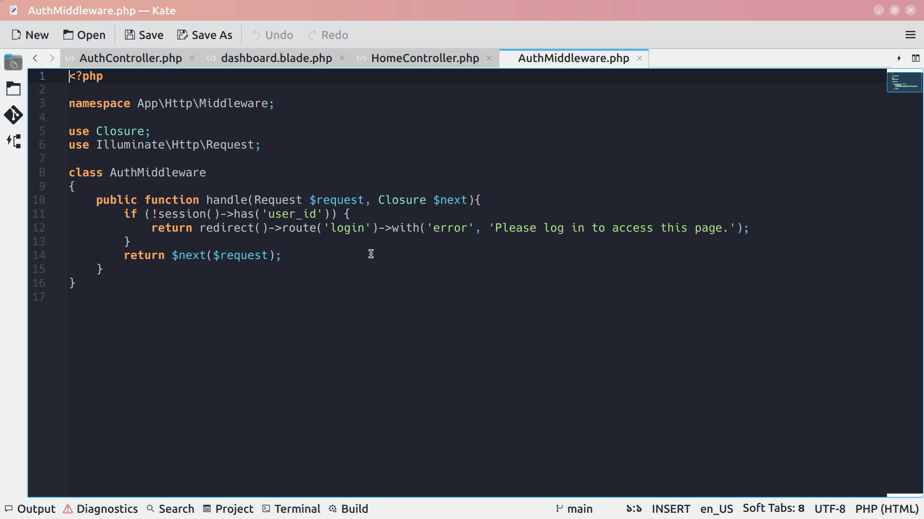
Here check user login info.

3.Design Decision:

1.Card Structure :Keeps content organized by topic,easy to query in database,
scales well when users have many cards
2.Spaced Repetition Scheduling: App shows cards at optimal times, improves memory retention

4.Bug & How fixed:

-> I faced some bugs one of them was login issue when i give data for login it don’t store it
It was database management issue. Solved in migration files.

